HORATI 2017- THE WORLD'S FAIR OF ISRAELI FOLK DANCE, JUNE 8-11, 2017
Queens College, New York City
Horati 2017, a four day premier event bringing the world together through dance and housed at Queens College in New York City, will feature workshops that share the best of traditional and contemporary Israeli folk dance and music. Like a world’s fair, the offerings will include representations of the many cultures that Jews have embraced, adapted, and brought to Israel. Israeli folk dance enthusiasts and performing groups will be traveling from Israel and across the globe, including, for the first time, Galgal Ba'ma'agal, an inspiring group of Israeli wheelchair folk dancers who will perform, participate and share instructional methodologies. Horati 2017 will culminate with a gala multimedia performance.
We are thrilled to announce that six of Israel’s most beloved choreographers whose creativity continues to enrich our repertoire of Israeli folk dances will be joining us!
Shlomo Maman, Avi Peretz, Roni Siman Tov, Avner Naim, Israel Shiker and Yaron Elfasy
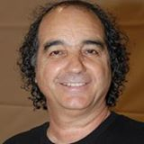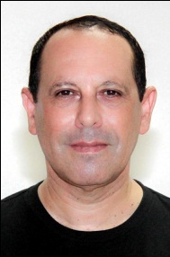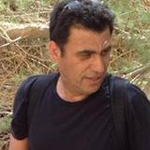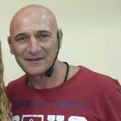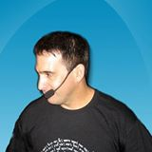

We are delighted to also welcome Israeli singer, Nadav Kakon
For full program, housing and registration details, please contact us:
Email: Horati2017@israelidanceinstitute.org
Israeli Dance Institute
JCRC - Suite 1607
225 West 34th Street, New York, NY 10122
Website: www.israelidanceinstitute.org
We look forward to welcoming you to Horati 2017!

So much to see, so much to do, it takes an entire a weekend to present!

